Types of Modems
# Source: AI Source: Provided by: [Data Path: Persons Table -> ID Column: 1, Name_En Column: Motasem Essam] -> From: [ChatGPT] on [12/18/2025]
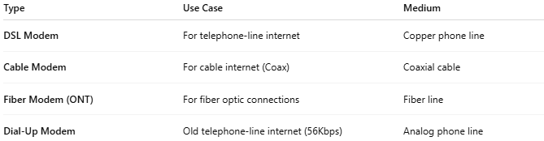

Type | Use Case | Medium
DSL Modem | For telephone-line internet | Copper phone line
Cable Modem | For cable internet (Coax) | Coaxial cable
Fiber Modem (ONT) | For fiber optic connections | Fiber line
Dial-Up Modem | Old telephone-line internet (56Kbps) | Analog phone line

